**ASSIGNMENT 1   
PAPER RECYCLING PROBLEM  
WORKER SCHEDULING PROBLEM**

**Advanced mathematical modeling for managerial decisions**

Instructor: Prof. Sachin Jayaswal

Academic Associate: Jaydeep Gohel

**Submitted by: Group 4**Aakash R – PC20200001

Prashant Ahirwar – PC20200049

Pratham Naik – PC20200050

Preetam Kumar – PC20200147

Date: July 11, 2021

**INDIAN INSTITUTE OF MANAGEMENT, AHMEDABAD**

# Paper Recycling Problem

**Q1. Consider the Paper Recycling problem, as discussed in class. Reformulate the problem using the following decision variables: 𝑦𝑖p = tons of input i processed using process p; 𝑥𝑖g= tons of pulp produced for grade g from input i.**

**Model:** Please refer to the folder “Q1” for the code files

**Indices:**

i: Input material  
p: Process  
g: Grade

**Parameters:**

Ci : Cost per ton for input i  
PCi : Fraction of pulp content in input i  
Qp : Cost of processing inputs using process p per ton of input  
Ep : Fraction of original pulp extracted by process p  
Kp : Capacity in tons of input for process p  
Dg : Tons of pulp required for producing grade g  
Fgi : 1 if input i can be used to produce grade g, 0 otherwise

**Variables:**

Yip : tons of input i processed using process p  
Xig : tons of pulp produced for grade g from input i

**Objective:**

Minimize cost: $\sum_{i}{\sum_{p}{\text{(C}\text{i} \text{+ }\text{Q}\text{p}\text{) × Y}\text{i}\text{p}}}$

**Constraints:**

1. Yip >= 0
2. Xig >= 0
3. Total input processed using process p should be less than the capacity of process p $\sum_{i}{\text{Y}\text{ip}}$ 
    <= Kp
4. Total output for grade g should be greater than or equal to the demand for grade g $\sum_{i}{\text{X}\text{ig}}$ 
    >= Dg
5. Pulp extracted from input i should be sufficient to fulfil the allocation across grades $\sum_{\text{p}}{\text{PC}\text{i} \text{×} }\text{E}\text{p }\text{×} \text{Y}\text{ip}$ 
   >= $\sum_{g}{\text{X}\text{ig}}$
6. Restrict the production of grade g to only the feasible inputs   
   Xig <= Fgi Dg

**Results:**

Cost = 140000

Y :=

1 1 0

1 2 0

2 1 0

2 2 0

3 1 0

3 2 2500

4 1 2333.33

4 2 500

X :=

1 1 0

1 2 0

1 3 0

2 1 0

2 2 0

2 3 0

3 1 0

3 2 0

3 3 600

4 1 500

4 2 500  
4 3 0

# Worker Scheduling Problem

**Q2. Consider the Worker Scheduling problem, as discussed in class. Solve using AMPL the alternate models developed in class for the following versions of the problem:**

**2A: Minimize the Maximum Excess:**

**Part 1: The Nonlinear formulation: solve it using the CPLEX solver**

**Model:** Please refer to the folder “Q2a(i)” for the code files

**Indices:**

w : Day index, w=1 corresponds to Monday, so on and so forth.

**Parameters:**

Reqw : The minimum number of employees required to work on day “w”

n : The number of consecutive days required by an employee to work

**Variable list:**

Xw : The number of employees starting work on day “w”

Aw : The number of employees coming to work on day “w”

**Objective function:**

Minimize (Maximum of (Aw – Reqw)), where w ∈ [1,7]

**Constraints:**

1. Constraint - For Linking Aw and Xw
2. Constraint – Availability of workers on the day should be greater than requirement
$$\sum_{i=0}^{\left(n-1\right)}{X_{w-i} >= {Req}_{w} , ∀ w}$$

3. Constraint – Non negativity (No. of workers starting on a particular date cannot be negative)

Xw >= 0, $∀ w$

**Results:**

The Cplex solver did not produce any results. It was displaying the error that the problem contains a non-linear objective function.

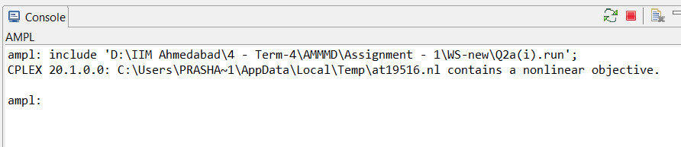

Figure Cplex Non- linear problem error

**Part 2: The Nonlinear formulation: solve it using the MINOS solver**

**Model:** Please refer to the folder “Q2a(ii)” for the code files

**Results:**

The max excess in a day comes out to be 2.333 with the following values of Xw:

1 3.66667

2 5.33333

3 0

4 7.33333

5 0

6 3.33333

7 2.66667

This is a local minima and not global minima. We tried to use other solvers like Baron, Gurobi, etc. but they were not compatible with the model.

**Part 3: The Linear Formulation: solve it using the CPLEX solver**

**Model:** Please refer to the folder “Q2a(iii)” for the code files

**Indices:**

w : Day index, w=1 corresponds to Monday, so on and so forth.

**Parameters:**

Reqw : The minimum number of employees required to work on day ‘w’

n : The number of consecutive days required by an employee to work

**Variable list:**

Xw : The number of employees starting work on day “w”

Aw : The number of employees coming to work on day “w”

z : max excess of workers in a day of the week

**Objective function:**

Minimize (z)

**Constraints:**

1. Constraint - Maximum excess in a day >= Excess on any particular day of the week

z >= Aw - Reqw

1. Constraint - Workers on a particular day are greater than the requirement

Aw >= Reqw,

1. Constraint - For linking Aw and Xw
2. Constraint – Non negativity (No. of workers starting on a particular date cannot be negative)

Xw >= 0 $, ∀ w$

**Results:**

Max excess in a day = 2.285714286 for the following values of Xw

1 3.71429

2 5.42857

3 0

4 7.14286

5 0

6 3.42857

7 2.71429

## **2B: Minimize the Total deviation**

## **Part 1: Non-Linear Formulation:**

**Model:** Please refer to the folder “Q2b Nonlinear” for the code files**.**

**Indices:**

w : Day index, w=1 corresponds to Monday, so on and so forth.

i : Lag index, used in calculating no of workers attending on a given day “w’

**Parameters:**

Reqw : The minimum number of employees required to work on day “w”

n : The number of consecutive days required by an employee to work

**Variable list:**

Xw : The number of employees starting work on day “w”

Aw : The number of employees coming to work on day “w”

Below given are the Objective function and the constraints of the model.

**Objective function:**

**Minimize $\sum_{w=1}^{7}{\left|A_{w}-Req_{w}\right|}$** , here A(*w*) refers to the attendance on day “w”.

**Constraints:**

1. | Constraint calculates attendance basis Xw

**Results:**

Cplex solver did not produce any solution to the problem, error provided in the figure below (The solutions provided was a **vector of 0s** for the **variable *X***). The Minos non-linear solver ignored the integral constraints placed on the variable X and gave the below minimum deviation. It should be noted that ***this is not the global minimum solution***. The solver ***“Baron”*** gives the global minimum solution to be ***7*** (In correspondence with the linear model results presented in the next sections)*.*

Total_Deviations = 11.6273

X [*] :=

1 9.65237

2 0.0250897

3 3.65237

4 5.67017

5 0

6 1.67746

7 0

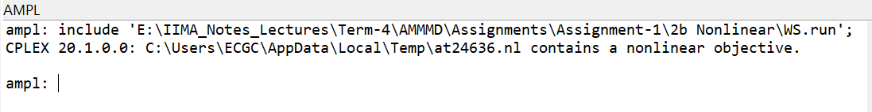

Figure Cplex Non-linear problem error

## **Part 2: Linear Formulation – Method 1:**

**Model:** Please refer to the folder “Q2b Linear Method-1” for the code files.

**Indices:** Same as the list mentioned previously

**Parameters:** Same as the list mentioned previously

**Variable list:**

Xw : The number of employees starting work on day “w”

Excess*w* : The number of employees in excess on day “w”

Short*w* : The number of employees in shortage on day “w”.

**Objective function:**

**Minimize $\sum_{w=1}^{7}{Excess_{w}}+Short_{w}$**

**Constraints:**

1. | This constraint equates attendance roll to requirement.

$Excess_{w}>0, ∀w$

$Short_{w}>0, ∀w$

$X_{w}>0, ∀ w$

$X_{w} is an Integer, ∀ w$

**Results:**

The model was solved using the Cplex solver, the results of the same are mentioned below.

Total_Deviations = 7

X [*] :=

1 6

2 5

3 1

4 7

5 0

6 3

7 0

## **Part 3: Linear Formulation – Method 2:**

**Model:** Please refer to the folder “Q2b Linear Method-2” for the code files.

**Indices:** Same as the list mentioned previously

**Parameters:** Same as the list mentioned previously

**Variable list:**

Xw : The number of employees starting work on day “w”

Dev*w*  : The deviation from the required number of employees on day “w”

Below given are the Objective function and the constraints of the model.

**Objective function:**

**Minimize $\sum_{w=1}^{7}{Dev_{w}}$**

**Constraints:**

1. | This along with the 2nd constraint models the max function behaviour.

$-\sum_{i=0}^{\left(n-1\right)}{X_{w-i}}+Req_{w}≤D{\text{ev}}_{w}, ∀w$

$X_{w}>0, ∀ w$

$X_{w} is an Integer, ∀ w$

**Results:**

Cplex solver gave the below mentioned result.

Total_Deviations = 7

X [*] :=

1 5

2 6

3 0

4 7

5 0

6 3

7 1